Assignment – 7
Forward Chaining Algorithm

Problem Statement:
The Forward Chaining Algorithm is a data-driven inference method used in rule-based systems and expert systems. It starts with a set of known facts and applies rules to derive new facts until a specific goal is reached or no more new facts can be generated. This algorithm is particularly useful in scenarios like production systems, where conclusions are drawn from available data.

Software used:
- Python 3.x
- Google Colab

Libraries and packages used:
- NumPy: For data handling and processing (optional)
- Pandas: For managing rules and facts in a structured manner.

Theory:
Forward chaining is a method of reasoning that begins with the available facts and applies inference rules to extract more data until a specific goal is reached. The main components of the forward chaining algorithm are:
- Facts: The initial data or information available in the system.
- Rules: Conditional statements that define how facts can be used to infer new facts. They are typically in the form of "IF condition THEN conclusion."
Working Mechanism:
- Start with a list of known facts.
- Repeatedly apply rules to the known facts.
- For each rule, if the conditions (antecedents) are met, the rule is fired, and new facts are added to the knowledge base.
- Continue this process until no new facts can be inferred or a specified goal is reached.

Methodology:
- Define the Knowledge Base: Create a set of initial facts and rules that represent the domain of interest.
- Implement the Forward Chaining Algorithm:
- Initialize a list of known facts.
- Continuously check each rule against the current set of facts.
- If the antecedent of a rule matches the known facts, infer the conclusion and add it to the list of known facts.
- Repeat until no new facts can be derived.
- Goal Checking: If there is a specific goal, check if the goal is present in the facts after each inference step.

Advantages:
- Simplicity: Forward chaining is straightforward to implement and understand.
- Data-Driven: It is well-suited for situations where data is readily available and conclusions can be drawn from it.
- Complete: If the rules are exhaustive and applicable, it can derive all possible conclusions from the known facts.

Limitations:
- Inefficiency: It can be inefficient if the rule set is large, as all rules are checked against the known facts repeatedly.
- No Backtracking: Forward chaining does not reconsider previous conclusions; once a rule is applied, it cannot be undone.
- Potential Redundancy: It may generate redundant conclusions if not designed carefully.

Applications with example:
- Expert Systems: Forward chaining is commonly used in expert systems to derive conclusions from medical data or diagnostic rules.
- Production Rules: Used in automated systems for manufacturing and inventory management to infer inventory levels and reorder requirements.
Example: Suppose we have the following facts and rules in a simple climate prediction system:
- Facts:
  - It is raining.
  - The temperature is below 60°F.
- Rules:
- If it is raining and the temperature is below 60°F, then the forecast is "cold and wet."
- If the temperature is below 60°F, then the forecast is "cool."
Given the initial facts, the algorithm would derive:
- "cold and wet" (from Rule 1)
- "cool" (from Rule 2)

Working / Algorithm:
- Define Facts and Rules: Create a list of initial facts and rules.
- Implement the Forward Chaining Function: Create a function to apply the forward chaining algorithm.
- Execute the Algorithm: In the main function, invoke the forward chaining process and display results.

Diagram:
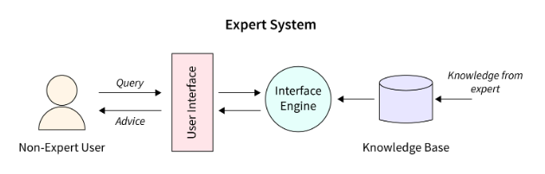
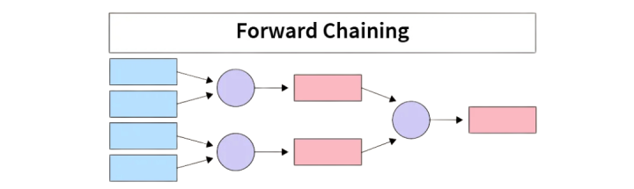

Conclusion:
The Forward Chaining Algorithm is an essential technique in artificial intelligence for deriving conclusions from available data. It provides a clear method for inferring new facts based on existing knowledge through a rule-based approach. While it is simple and effective for many applications, awareness of its limitations is crucial for implementing it effectively in real-world scenarios. The approach showcases the power of logic and inference in AI and forms a foundational aspect of expert systems.

